AP Calculus-AB Limits, Continuity, & R.O.C Day 10

Notes: Derivative as a Function

Example(s) 1:

For the function given, arrange the following numbers from least to greatest.

$f^{'}\left(-5\right),{ f}^{'}\left(-3.5\right), { f}^{'}\left(-2\right), f^{'}\left(.5\right), { f}^{'}\left(3\right) \& f(4)$

1. Sketch a graph of the derivative on top of $f(x)$.



|  |  |
| --- | --- |
| What do you know about $f(x)$? | What does it tell you about $f'(x)$? |
|  |  |
|  |  |
|  |  |
|  |  |
|  |  |

Example(s) 2:

Sketch the graph of $f'(x)$ given the graph of f(x).

|  |  |
| --- | --- |
|  |  |
|  |  |

Differentiability:

We say that a function is differentiable at a point if a derivative is defined at the point. A function  will fail to be differentiable at  if

*  is discontinuous at ,
*  has a cusp or corner at , or
*  has a vertical tangent at 

Example(s) 3:

State where each function is not differentiable and why.

[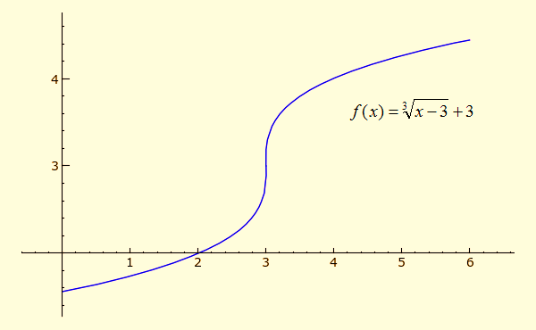](http://www.google.com/url?sa=i&rct=j&q=&esrc=s&source=images&cd=&cad=rja&uact=8&docid=4A_onbu3_bNPlM&tbnid=GfMcXfBRqdtdJM:&ved=0CAUQjRw&url=http://www.sagemath.org/calctut/differentiability.html&ei=ZrDPU5CCMPbKsQSdoIC4CQ&bvm=bv.71667212,d.cWc&psig=AFQjCNHea2wl0fFdmf_9OBZv-4yRcKv0gw&ust=1406205888415736)

[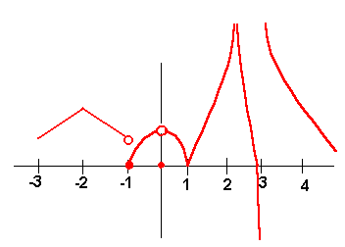](http://www.google.com/url?sa=i&rct=j&q=&esrc=s&source=images&cd=&cad=rja&uact=8&docid=riwX4MnI59WW0M&tbnid=_d6sc4gdkUVJ9M:&ved=0CAUQjRw&url=http://www.ltcconline.net/greenl/courses/115/keys/pFinal.htm&ei=Hq3PU-CEJ4fJsQTR1YKYAw&bvm=bv.71667212,d.cWc&psig=AFQjCNFoaJtyWiDMtEll0PhARTKI35xDAg&ust=1406205311550021)

[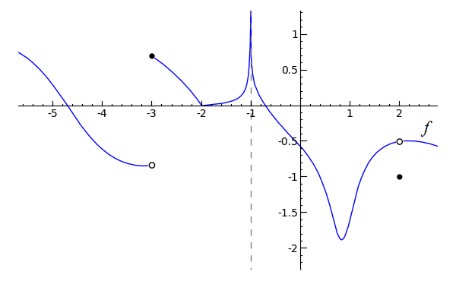](http://www.google.com/url?sa=i&rct=j&q=&esrc=s&source=images&cd=&cad=rja&uact=8&docid=MqgD9gOX1jbl_M&tbnid=82Bmgf6wDz1lbM:&ved=0CAUQjRw&url=http://www.sagemath.org/calctut/onesided.html&ei=m63PU9L2DsnLsQTdh4CgDA&bvm=bv.71667212,d.cWc&psig=AFQjCNE-WeYT97DmVQW4WJw7yRa6SF4xTg&ust=1406205701882831)

[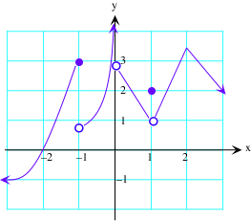](http://www.google.com/url?sa=i&rct=j&q=&esrc=s&source=images&cd=&cad=rja&uact=8&docid=MqgD9gOX1jbl_M&tbnid=82Bmgf6wDz1lbM:&ved=0CAUQjRw&url=http://www.zweigmedia.com/RealWorld/calctopic1/contanddiff.html&ei=m63PU9L2DsnLsQTdh4CgDA&bvm=bv.71667212,d.cWc&psig=AFQjCNE-WeYT97DmVQW4WJw7yRa6SF4xTg&ust=1406205701882831)

[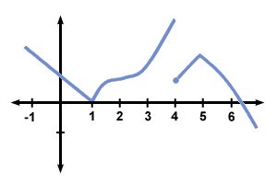](http://www.google.com/url?sa=i&rct=j&q=&esrc=s&source=images&cd=&cad=rja&uact=8&docid=riwX4MnI59WW0M&tbnid=_d6sc4gdkUVJ9M:&ved=0CAUQjRw&url=http://www.sparknotes.com/math/calcbc1/thederivative/problems.html&ei=tqzPU7nOB9XNsQSbrICIAg&bvm=bv.71667212,d.cWc&psig=AFQjCNFoaJtyWiDMtEll0PhARTKI35xDAg&ust=1406205311550021)

[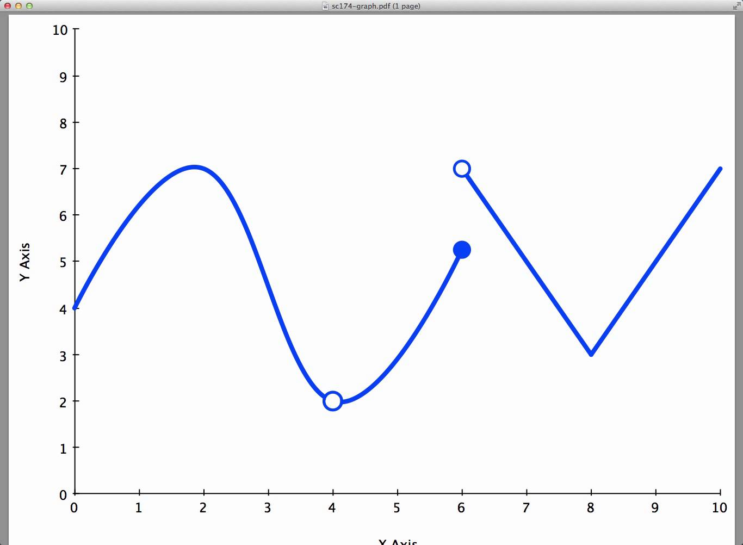](http://www.google.com/url?sa=i&rct=j&q=&esrc=s&source=images&cd=&cad=rja&uact=8&docid=riwX4MnI59WW0M&tbnid=_d6sc4gdkUVJ9M:&ved=0CAUQjRw&url=http://www.youtube.com/watch?v%3D_vimObBaJxI&ei=OKzPU8S6LKnLsQS35oKADg&bvm=bv.71667212,d.cWc&psig=AFQjCNFoaJtyWiDMtEll0PhARTKI35xDAg&ust=1406205311550021)