Look at the graph. State where the graph is not differentiable and why. | 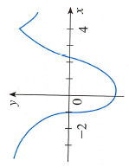 |  | X=  Because  X=  Because  X=  Because
Look at the graph. State where the graph is not differentiable and why. |  |  | X=  Because  X=  Because  X=  Because
Look at the graph. State where the graph is not differentiable and why. |  |  | X=  Because  X=  Because  X=  Because

