AP Calculus AB Name________________________
Derivative as a Function Limits, Cont., & R.O.C Day 10
1. For the function $g$ whose graph is given, arrange the following numbers in increasing order and explain your reasoning.  $$0 g^{'}\left(-2\right) g^{'}\left(0\right) g^{'}\left(2\right) g'(4)$$ | 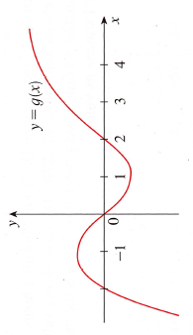

2. Match the graph of each function in A.)-D.) with the graph of the derivative in I-IV. Give reasons for your choices.
A.)  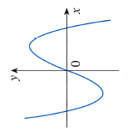 | B.)  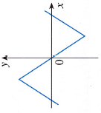 | I.)  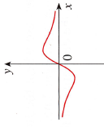 | II.)  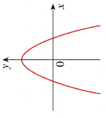
C.)  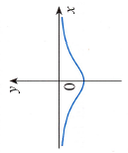 | D.)  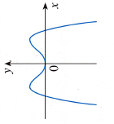 | III.)  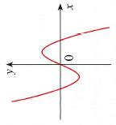 | IV.)  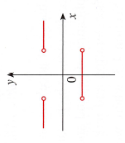

3.-7: Use the given graph to sketch the graph of $f$. | 3.  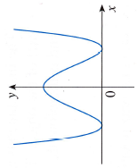 | 4.  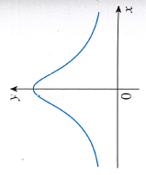

AP Calculus AB Name________________________
Derivative as a Function Limits, Cont., & R.O.C Day 10

5.-7:Use the given graph to sketch the graph of $f$.
5.  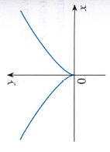 | 6.  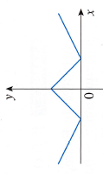 | 7.  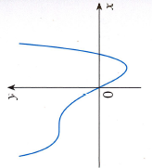

8.-11: The graph of $f$ is given. State, with reasons, the numbers at which $f$ is not differentiable.
8.  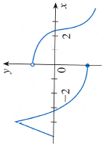 | 9.  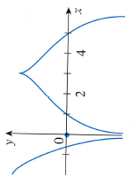
10.  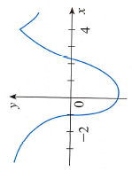 | 11.  