AP Calculus Name_____________________________

Trigonometric Integrals Additional Techniques of Integration Day 1

Evaluate the integral

|  |  |
| --- | --- |
| 1. | 2. |
| 3. | 4. |

AP Calculus Name_____________________________

Trigonometric Integrals Additional Techniques of Integration Day 1

Evaluate the integral

|  |  |
| --- | --- |
| 5. | 6. |
| 7. | 8. |

AP Calculus Name_____________________________

Trigonometric Integrals Additional Techniques of Integration Day 1

Answer Key:

|  |  |  |  |  |  |
| --- | --- | --- | --- | --- | --- |
| 1. |  | 2. |  | 3. |  |
| 4. |  | 5. |  | 6. |  |
| 7. |  | 8. |  |  |  |

Review of Finding Limits Graphically:

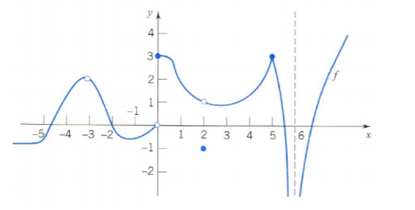

|  |  |  |  |  |
| --- | --- | --- | --- | --- |
| 1. | 2. | 3. | 4. | 5. |
| 6. | 7. | 8. | 9. |  |
| 10. | 11. | 12. | 13. |  |
| 14. | 15. | 16. | 17. |  |
| 18. | 19. | 20. | 21. | 22. |